Dorothy Day House of Hospitality, Inc.
Board of Directors and Advisors
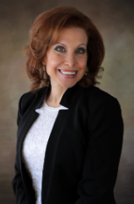
Anne-Louise DePalo, Co-President
Anne-Louise DePalo is a New York family law attorney with more than 30 years of experience guiding clients on Staten Island. Since receiving her law degree from Albany Law School, Anne-Louise DePalo has been appointed as a Co-Chairperson of the Matrimonial Committee at the Richmond County Bar Association. She is also a certified mediator and certified parent coordinator.
Anne-Louise is an active member in her community parish, St. Ann’s Church. She has hosted multiple events and programs such as the Catholic Divorce Survival Guide, the Bereavement Program, and many more. She works to provide support to those who are experiencing life altering events as well as providing guidance and help during traumatic and emotional times. Anne-Louise writes reflections for the St. Joseph Retreat Center on Staten Island during Advent and Lent.
As the current leader of the Dorothy Day Catholic Worker on Staten Island, Anne-Louise has dedicated many hours of service to those in need. She is also an advocate, coordinator and volunteer for the Springs of Love initiative, helping vulnerable foster/adoptive families on Staten Island. She is excited to spread awareness of these initiatives and to honor the legacy of Dorothy Day in her hometown of Staten Island as her canonization process progresses.

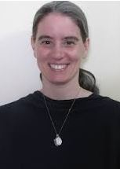
Deborah Sucich, Co-President
Deborah is a retired teacher and Campus Minister and has lived and worked among the poor in the New York City and Lancaster, PA Catholic Worker Houses. As a Consecrated Virgin for the Diocese of Brooklyn since 2019, she is actively serving in religious education, young adult outreach, work with abuse survivors, fertility education and the pro-life movement on Staten Island and Brooklyn as leader of the 40 Days for Life campaigns. Since 2013, she coordinates The Goretti Group New York Chapter which seeks to spread the message of chastity to young adults and to promote the authentic teachings of the Church on marriage & family life.

Deborah is a certified Fertility Education & Medical Management (FEMM) educator helping women of all ages and couples to understand their hormonal health and manage their fertility. Since 2020, she leads and is on the Board of Directors for the East Coast Chapter of the Maria Goretti Network (MGN) which helps those affected by abuse seeking healing and forgiveness.

Deborah admires Dorothy Day and Peter Maurin’s vision of hospitality, solidarity with the poor, and their radical commitment to justice by actively and peacefully resisting the evils of our day. She believes we can enhance human dignity and strengthen the bonds of the local community with deeper meaning and purpose by opening a Dorothy Day House of Hospitality and expanding the mission of the Catholic Worker movement on Staten Island.

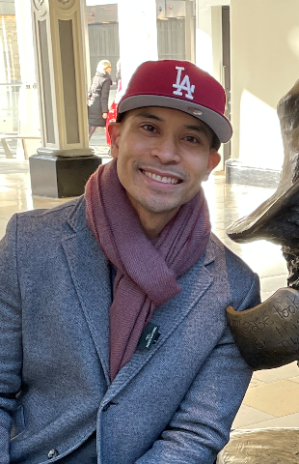
Mark Villamor, Secretary
Mark grew up in Los Angeles, CA where he earned a Bachelor of Science degree from the University of California, Irvine in Electrical Engineering. He worked in the government defense contracting industry as a Systems Engineer at Boeing and Northrop Grumman. He went on to receive a certificate in Applications Programming from the University of California, Los Angeles.
He was promoted to Software Manager where he supported engineers with supplemental training, performance improvement, mentoring and career placement. He was also a Control Account Manager where he submitted monthly earned value reports to the US Air Force. Mark supported multiple software engineering proposals for new engineering work as well as developing risk mitigation activities to lower program risk. After 14 years in defense contracting, he moved to New York City to work at Major League Baseball as a software director.
Mark is a member of the Knights of Columbus at Holy Name of Jesus Parish (#4783) in Windsor Terrace, Brooklyn. He received an Exemplary Service award for his work with the Brooklyn Witness for Life and was elected to serve as director of the council’s Life Committee. He currently volunteers as a sidewalk counselor for NYC Sidewalk Advocates for Life where he engages with mothers and fathers at abortion clinics, offering them alternative services at local pro-life pregnancy resource centers.

Omar Espinal, Treasurer
Omar has earned a BA in Theology and Pastoral Ministry from Brescia University and an AAS in Accounting from NYC College of Technology. He has a strong knowledge of the Catholic faith and is a faithful daily participant in the sacramental life of the Church. He has experience as a teacher assistant and has completed an internship with the St. Joseph House Catholic Worker in New York City.
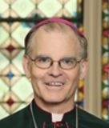
Bishop Peter J. Byrne, Spiritual Director
As auxiliary bishop of the Archdiocese of New York and vicar of the Staten Island region, Bishop Byrne has been one of the biggest supporters of the SI Catholic Worker.
He attended Immaculate Conception Elementary School in Manhattan and Cardinal Hayes High School in Bronx, New York. In 1983, he earned a BA from Fordham University, the Rose Hill (Bronx) campus, with a concentration in history/social studies.
Bishop Byrne entered the archdiocese’s major theologate, Saint Joseph’s Seminary in Yonkers, New York in 1974 and on December 1, 1984, was ordained a priest by Archbishop John O’Connor in Saint Patrick’s Cathedral.
In 1992, Cardinal O’Connor appointed Bishop Byrne as administrator for Saint Thomas Aquinas Parish in the Bronx and two years later, in 1994, Cardinal O’Connor appointed him administrator of Immaculate Conception and Saint John the Baptist Parishes on Staten Island, New York, becoming pastor in 1995. Since July 2013, he has served as pastor of Saint Elizabeth Parish in Manhattan. Following the World Trade Center tragedy of September 11, 2001, Father Byrne volunteered his priestly service to bereaved families for many weeks at the Ground Zero Morgue.
In 2013, Bishop Peter J. Byrne was ordained Auxiliary Bishop for the Archdiocese of New York by Cardinal Timothy Dolan.

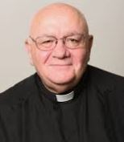
Monsignor Raymond. P. Roden, Founding Spiritual Advisor
Following studies at Immaculate Conception Seminary in Huntington, Fr. Roden was ordained a priest for the Diocese of Brooklyn in 1981 at the Parish of Ss. Peter and Paul in Williamsburg, Brooklyn, where he served as parochial vicar for six years. He then served as chaplain at Covenant House in Manhattan for three years, and chaplain for the NYC Department of Juvenile Justice at Spofford Juvenile Center in the Bronx for five years. In 1995, he was appointed Director of Campus Ministry at St. John’s Preparatory School in Astoria, NY.
He was then appointed Interim Vicar for Senior Clergy and Interim Director of The Bishop Mugavero Residence in Douglaston. Following his assignment as parochial vicar at St. Anthony-St. Alphonsus Parish in Greenpoint in 2001, he was appointed Special Assistant to the Vicar for Clergy for the Diocese of Brooklyn in 2004.
Over the years, he earned a B.A. degree in Spanish from St. Francis College; certification as a spiritual director from the Archdiocese of New York’s School of Spirituality; master’s degrees in pastoral counseling from Iona College and in applied psychology from Yeshiva University; and a doctoral degree in clinical psychology from Yeshiva University. In 2011, he was named Associate Spiritual Director at Cathedral Seminary House of Formation in Douglaston.
He was assigned as Pastor of Our Lady of Sorrows Parish, Corona, in 2015. Father Roden was named Chaplain to His Holiness on December 16, 2019. On June 30, 2020, he was once again appointed Spiritual Director at CSHF, Douglaston and is now retired and living in the Senior priest residence in Douglaston.

Michael Vento, Cross-Functional Consultant
In brief Michael, a native Staten Islander, has learned and draws from personal experiences across the US, Europe, Asia, and Latin America in industries including but not limited to non-profit, finance, technology, (adult and youth) education, media, and sales, both at large multinational corporations as well as small entrepreneurial organizations.
A few years ago, during weekday hours he was launching a new office and line of business for a financial institution. On nights and weekends, he was a live-in volunteer at a homeless shelter run by a Religious Order, visiting two Juvenile Detention Center, bringing Jesus in the Eucharist to the Hospital, visiting our Sisters and Brothers living on the street, etc.
Shortly after the project was a success, COVID hit and all the volunteer opportunities stopped. Looking back on it right now, this was a second experience creating in him an understanding that God did not want his money, God wanted him…
Michael recognizes a degree of how blessed he is, including to be brought back home as a part of witnessing Dorothy Day’s authentic Catholic simplicity in daily life to those in need of the Works of Mercy in her hometown for the 90th anniversary. He is excited to see what nurturing this seed from right now will yield in the short time that leads us to the 100-year mark, and beyond!

